Digital Nurture 4.0 – Week 8
GIT

Filename : 1. Git-HOL
Steps:
- Install Git.

- Check Git version:
git --version

- Set up Git user config:
git config --global user.name "yasirhameed786"
git config --global user.email "yasirhameed.i2004@gmail.com"

- Create new directory & initialize repo:
mkdir GitDemo
cd GitDemo
git init

- Create and add file:
echo "Welcome to Git" > welcome.txt
git status
git add welcome.txt

- Commit with message:
git commit

- Set up remote GitLab repository:
git remote add origin https://gitlab.com/yasirhameed786/GitDemo.git

- Pull from and push to remote:
git pull origin master
git push origin master

IN TERMINAL:

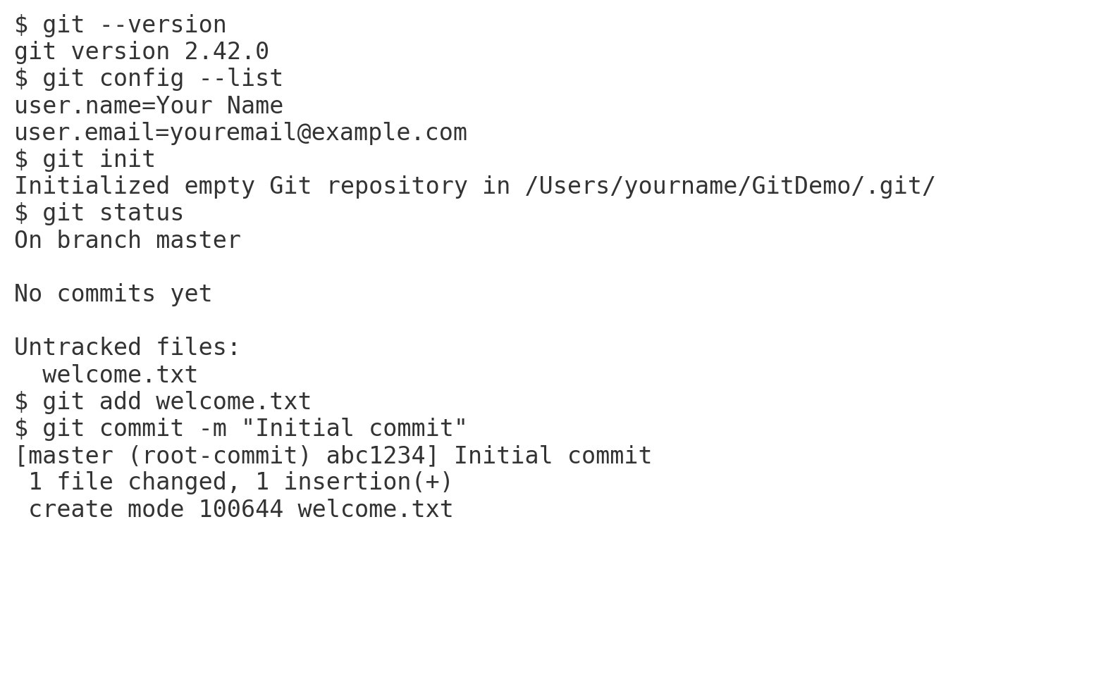
Filename : 2. Git-HOL
Steps:
1. Inside the GitDemo project directory:
cd GitDemo

2.Create .log file and log folder:
touch example.log
mkdir log

3.Create .gitignore file:
echo "*.log" > .gitignore
echo "log/" >> .gitignore

4.Check Git status:
git status

5.Add .gitignore and commit:
git add .gitignore
git commit -m "Ignore .log files and log folder"

IN TERMINAL:

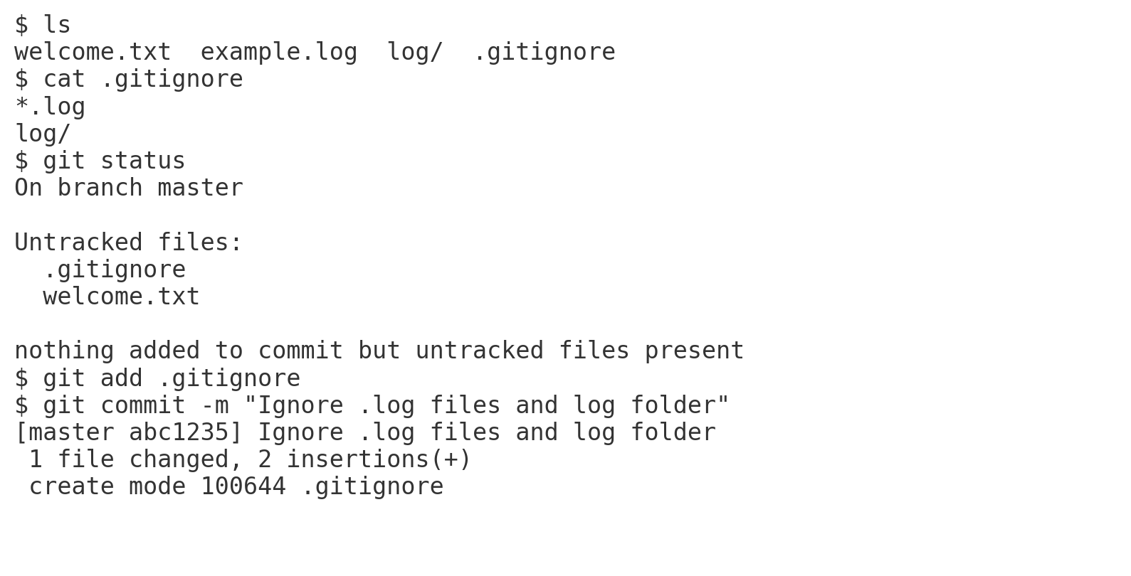
Filename : 3. Git-HOL
Steps:
1.Create branch and switch:
git checkout -b GitNewBranch

2.Add file and commit:
echo "This is a new branch file" > newbranch.txt
git add newbranch.txt
git commit -m "Added newbranch.txt in GitNewBranch"

3.Check status:
git status

4.Switch to master and merge:
git checkout master
git diff GitNewBranch
git merge GitNewBranch

5.View log as graph:
git log --oneline --graph --decorate

6.Delete branch:
git branch -d GitNewBranch

IN TERMINAL:

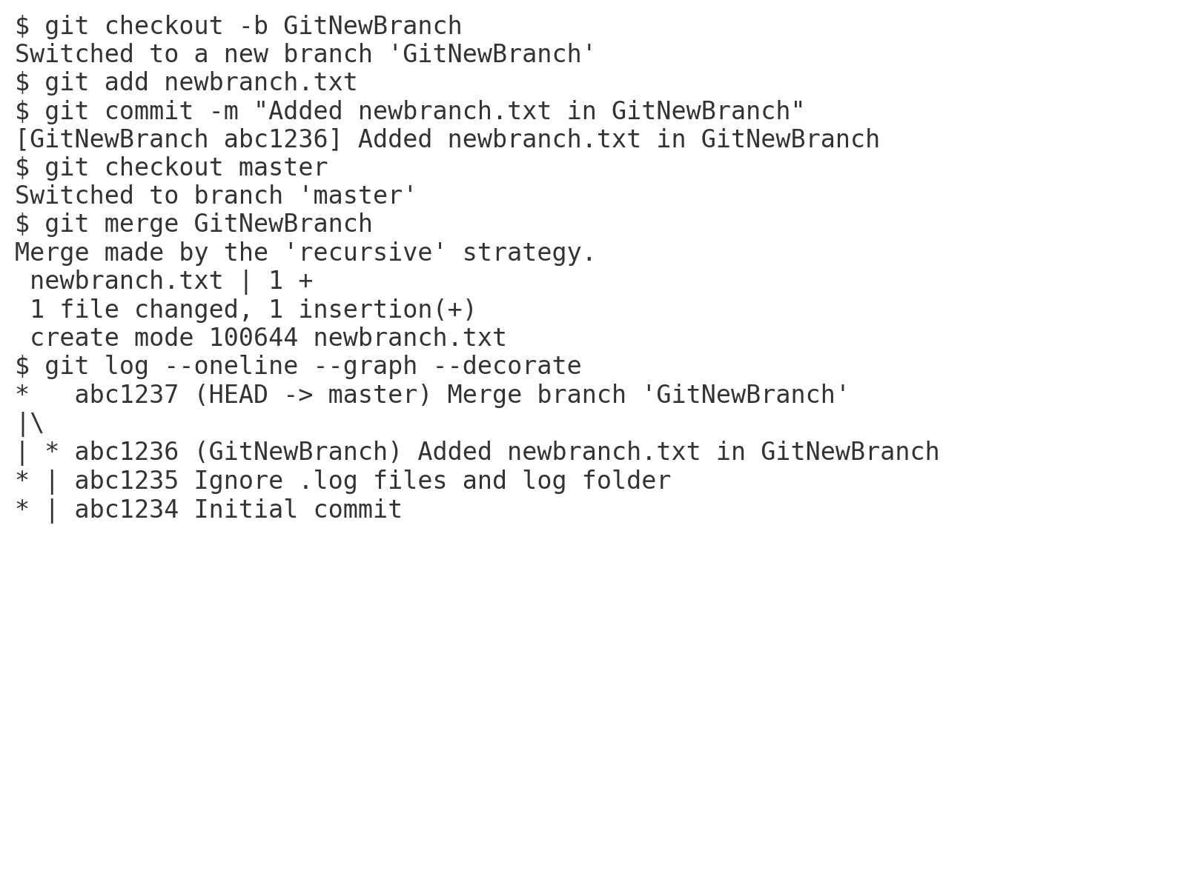
Filename : 4. Git-HOL
Steps:
1.Verify master is clean:
git status

2.Create GitWork branch and switch:
git checkout -b GitWork

3.Create and commit hello.xml:
echo "Branch version of XML" > hello.xml
git add hello.xml
git commit -m "Added hello.xml in GitWork"

4.Switch to master and create different hello.xml:
git checkout master
echo "Master version of XML" > hello.xml
git add hello.xml
git commit -m "Added hello.xml in master"

5.View history:
git log --oneline --graph --decorate --all
6.Check diff and attempt merge:
git diff GitWork
git merge GitWork

7.Resolve conflict manually:
nano hello.xml
git add hello.xml
git commit -m "Resolved conflict in hello.xml"

8.Add backup files to .gitignore:
echo "*~" >> .gitignore
git add .gitignore
git commit -m "Ignore backup files"

- Delete GitWork branch:
git branch -d GitWork
git log --oneline --graph --decorate

IN TERMINAL:
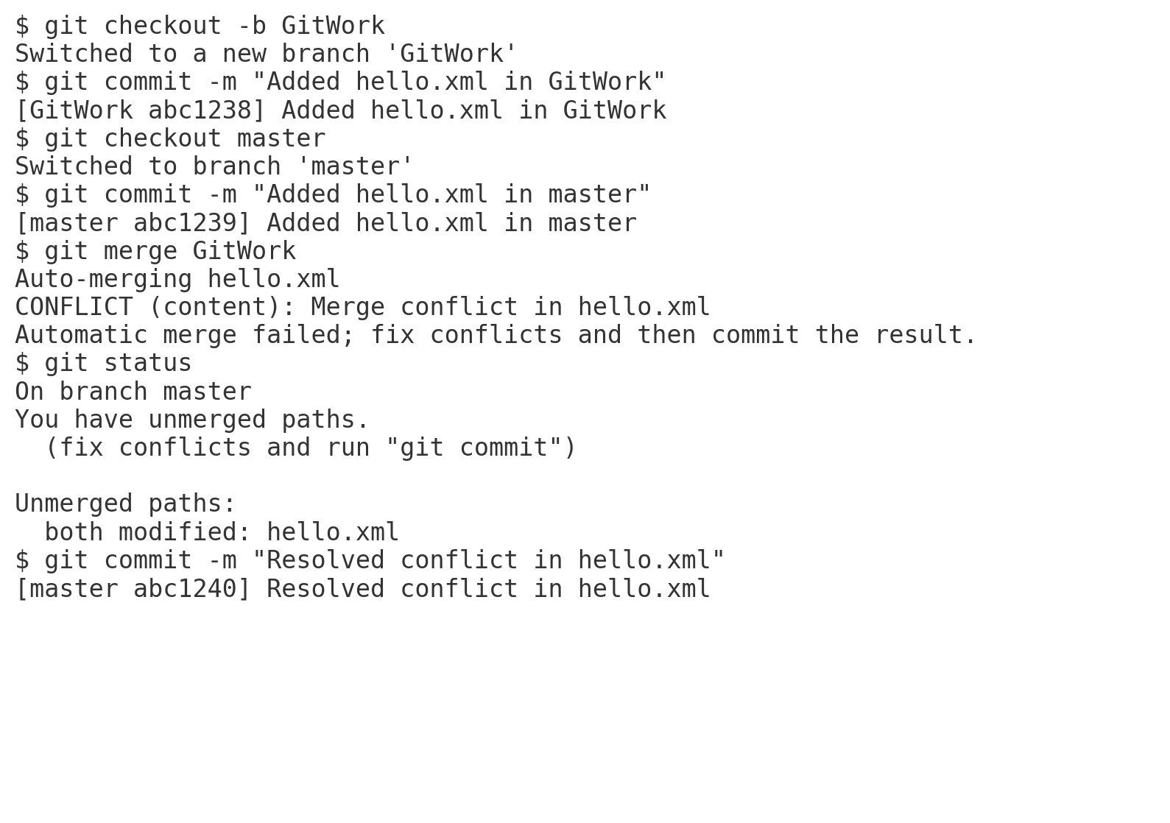
Filename : 5. Git-HOL
Steps:

1.Verify clean state:
git status

2.List branches:
git branch -a

3.Pull latest from remote:
git pull origin master

4.Push local changes:
git push origin master

5.Check changes reflected on GitLab

IN TERMINAL:

